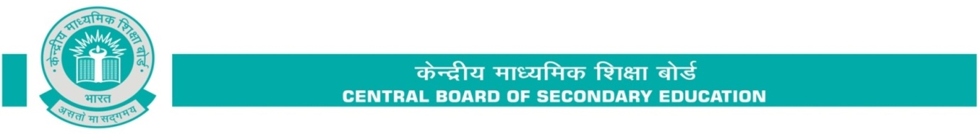

# Subject: Introduction of two levels of Mathematics for All India Secondary School Examination

The Board has decided to introduce two levels of examination in Mathematics for the students who are going to appear in the Board examination . The details of this scheme are as under :

* The two levels of Examination will be held in the subject of Mathematics in the Board examination for Class X in the year 2023-24 and the same shall **not** be applicable to the internal assessment in class X.
* There shall **not** be two levels of Assessment/Examination for class IX.
* First level would be the same as the existing one, and the other would be an easier level.
* The nomenclature for the two Examinations will be; Mathematics**-Standard** for the existing level of examination, and Mathematics*-***Basic** for the easier level of examination.
* The syllabus, class room teaching and internal assessment for both the levels of examination would remain the same; so that the students get an opportunity to study the whole range of topics throughout the year and are able to decide upon the level of Board examination depending upon their aptitude and abilities.
* **The *Standard* level will be meant for students who wish to opt for Mathematics at Sr. Secondary level and the *Basic* level would be for students not keen to pursue Mathematics at higher levels.**
* A student will have the right to choose between the two levels of Examination at the time of submission of List of Candidates (LoC) by the affiliated school to the Board online.
* In case student fails at any level of Mathematics, he/she can appear at the compartment examination as per norms of the Board according to the options given below:

|  |  |
| --- | --- |
| **In case of failure in** | **Compartment options** |
| Mathematics -Basic | Mathematics-Basic |
| Mathematics-Standard | Mathematics Standard or Mathematics- Basic |

* student who qualifies the Mathematics-Basic, shall be given an option to appear in Mathematics-Standard at the time of Compartment exams as per norms of the Board, in case he/she changes his/her mind to pursue Mathematics at Senior Secondary level.

Frequently Asked questions (FAQs) on the two level of Mathematics are enclosed for ready reference. Design for both the levels of question papers as per curriculum for the academic session ending March 2020 onwards will be made available on [www.cbseacademic.nic.in](http://www.cbseacademic.nic.in/) in due course of time. Detailed guidelines regarding the filling up of List of Candidates (LOC) for the examination in 2023-24 shall be issued separately to the affiliated schools at the time of filling up of LOC.